|  |  |
| --- | --- |
|  | **Qatar University**  **College of Engineering**  **Department of Computer Science and Engineering** |

**Mobile Application**

**Project Phase 1: YalaPay**

**Project Group Members:**

**Hanan Rashid – 202006354**

**Rain Alkai – 202005090**

**Arwa Alobeid-202102413**

* **Figma:**

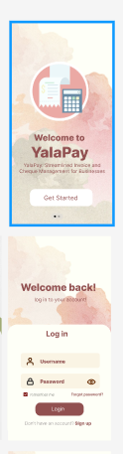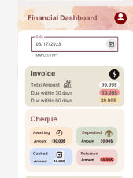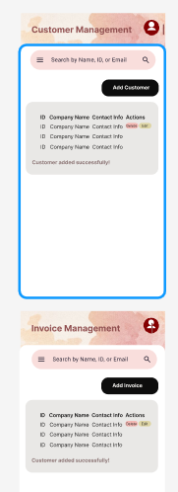

* **UI Screenshots:**
* 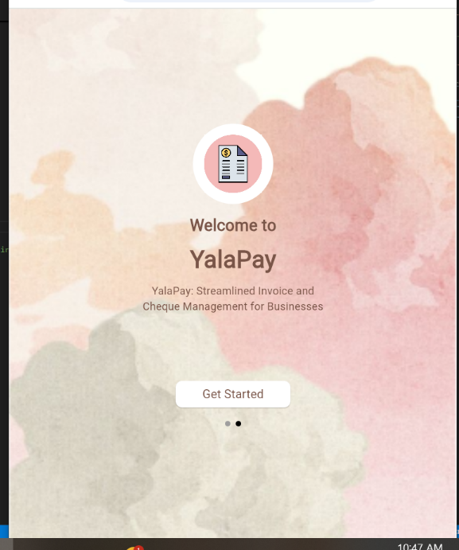Startscreen:
* Login:
* **Dashboard (Responsive):**

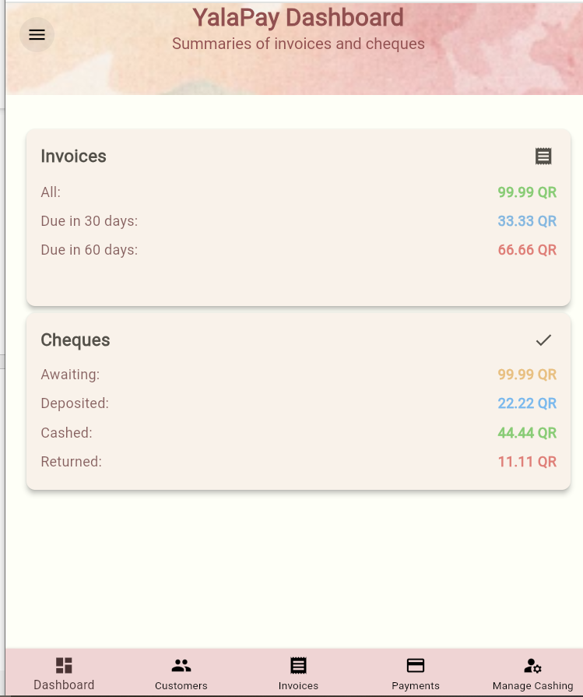 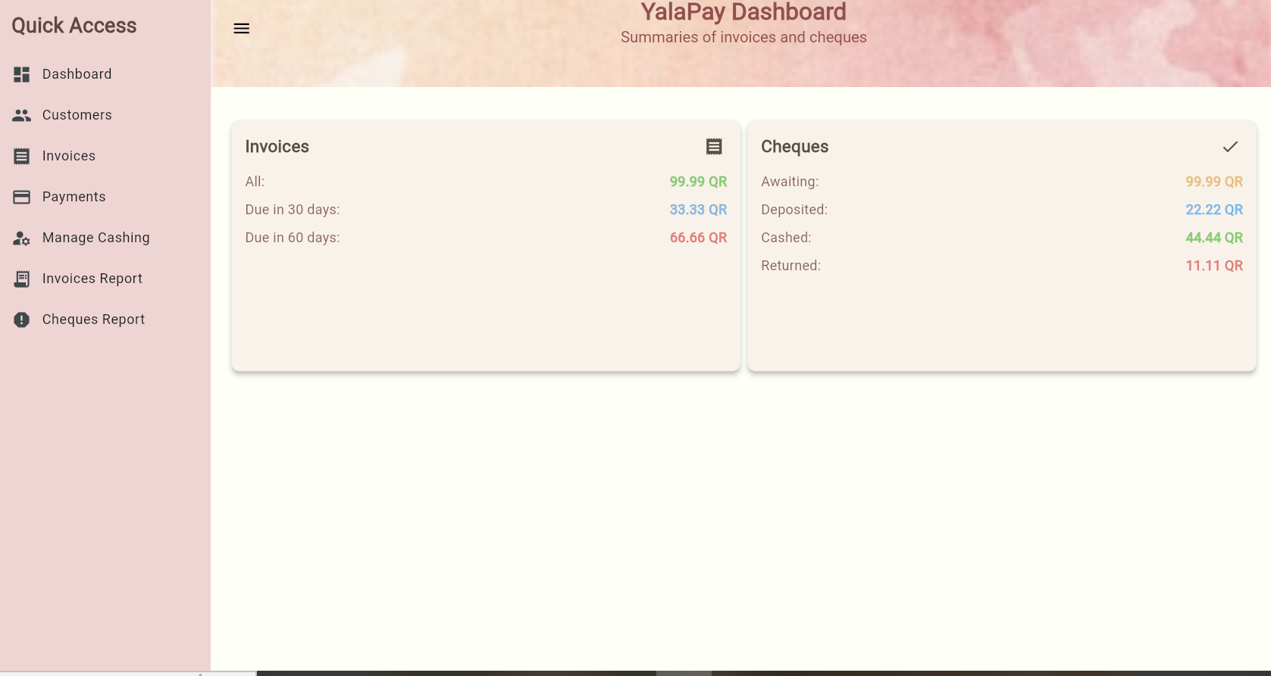

* 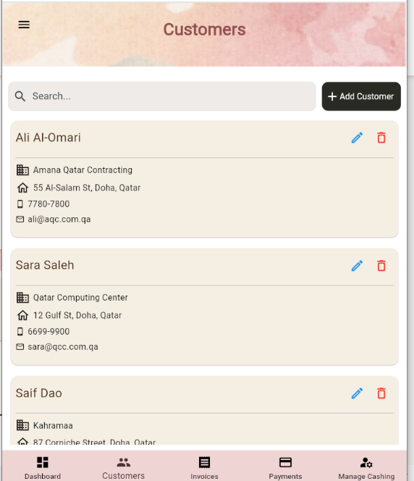Customers (Responsive) :

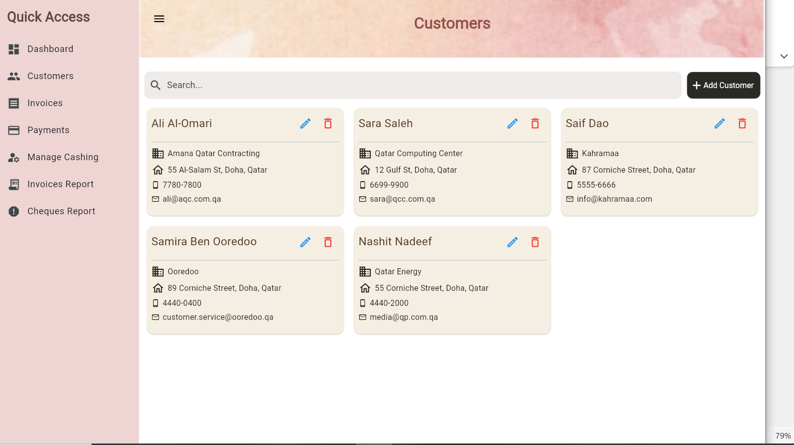

* **Customer Delete:**

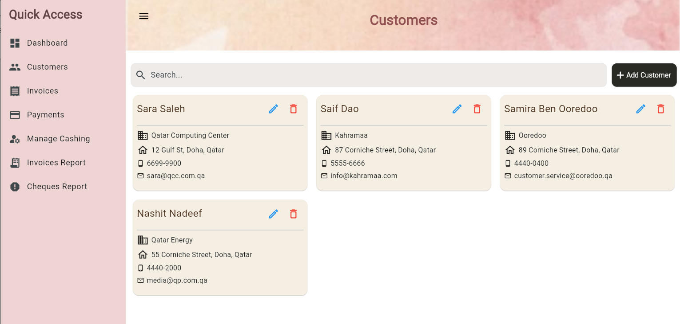

* **Customer Search:**

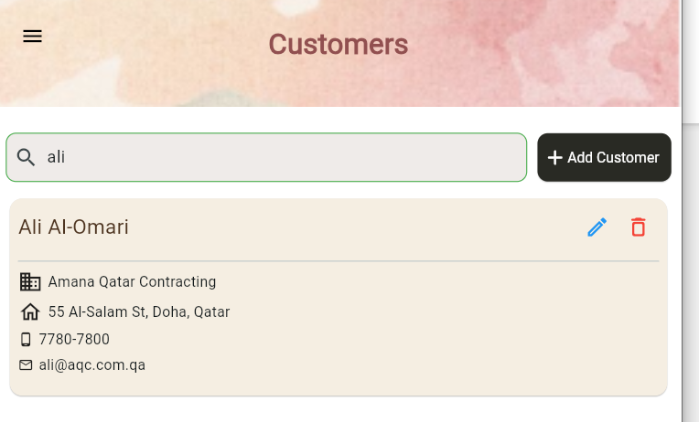

* **Customer Add:**

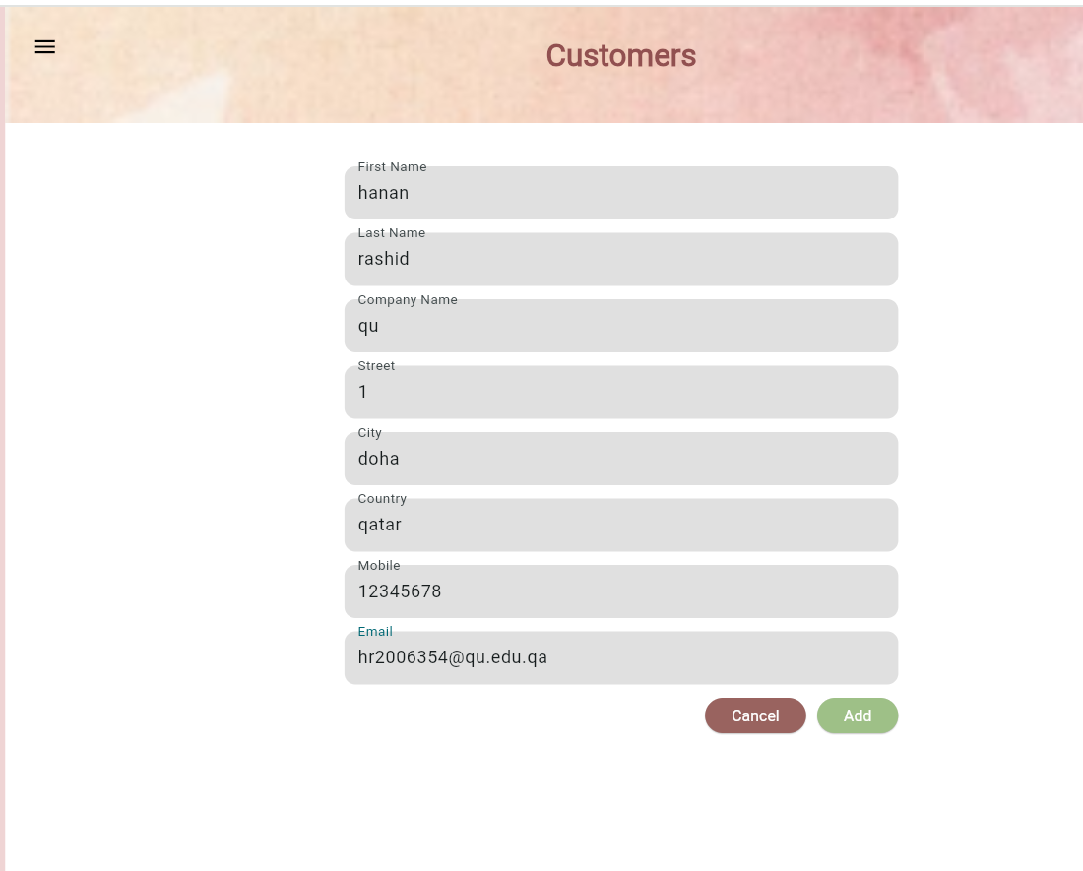

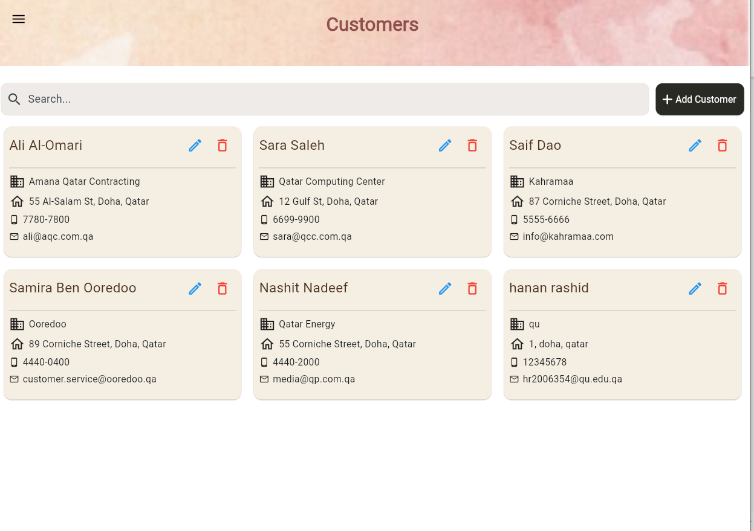

* **Customer Update:**

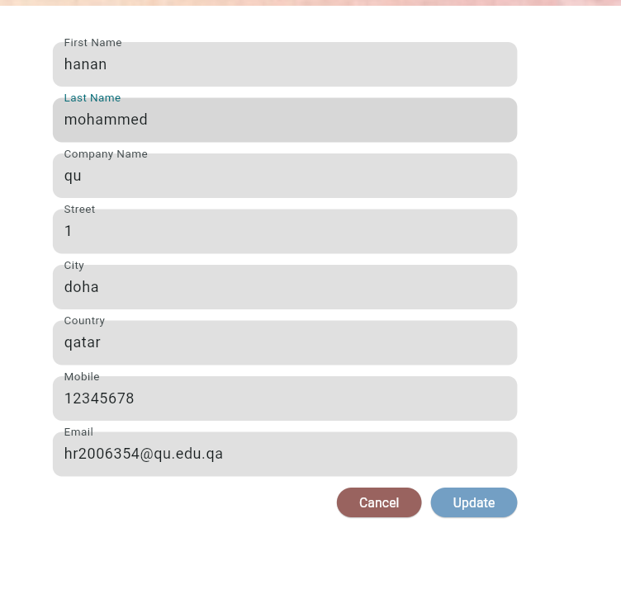

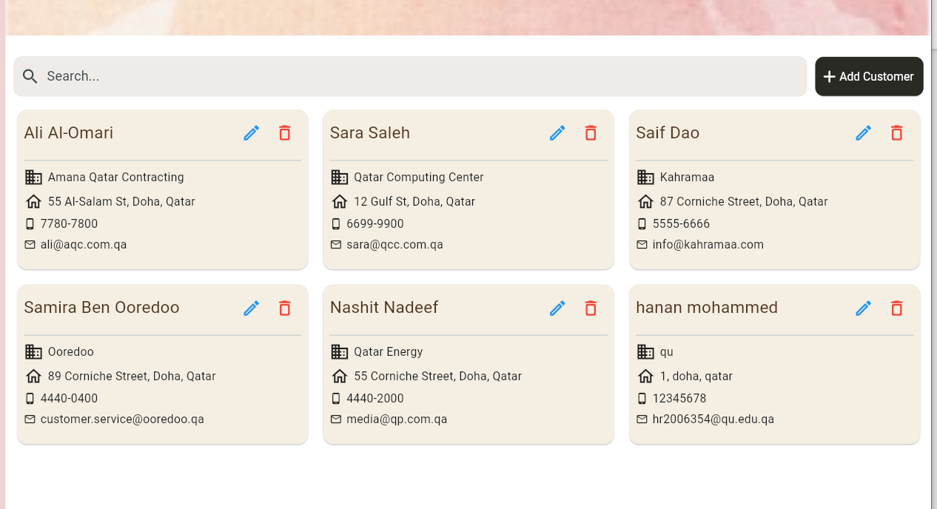

* **Invoices ( Responsive) :**

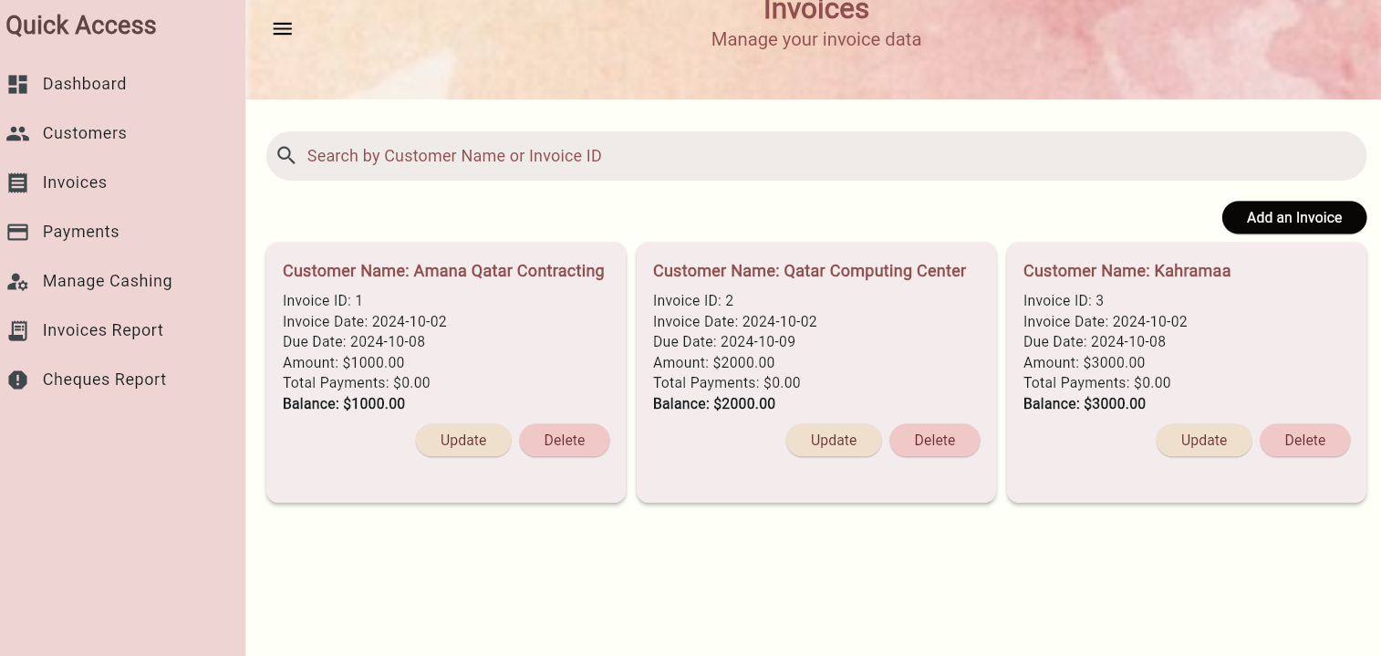

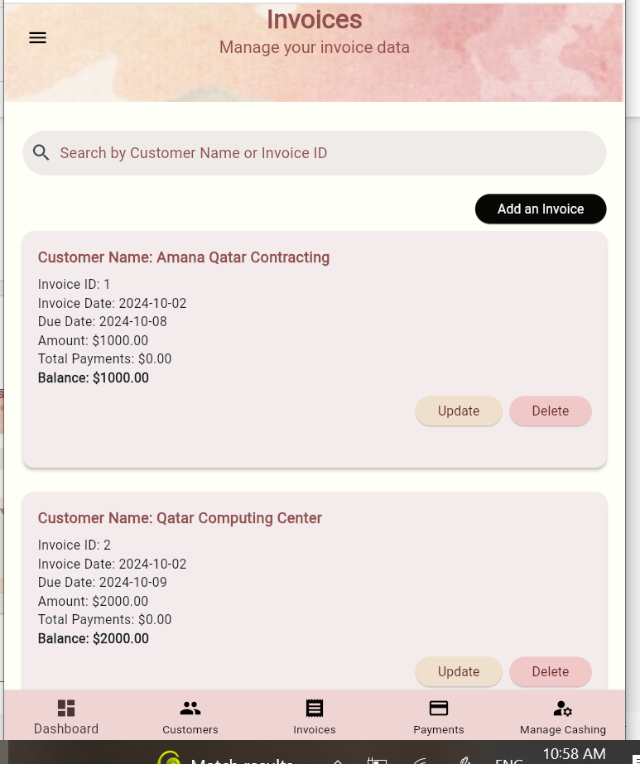

* **Delete invoice:**

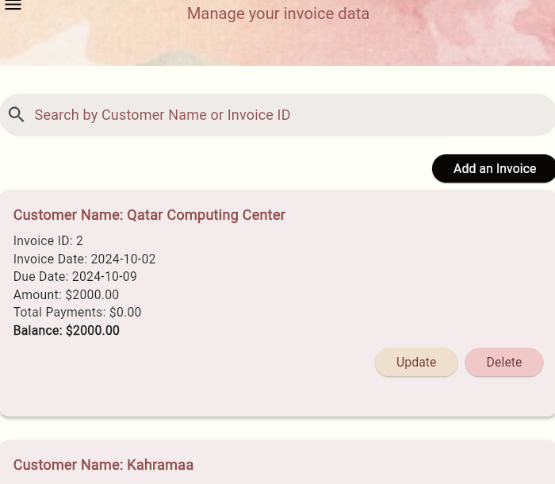

* **Add invoice:**

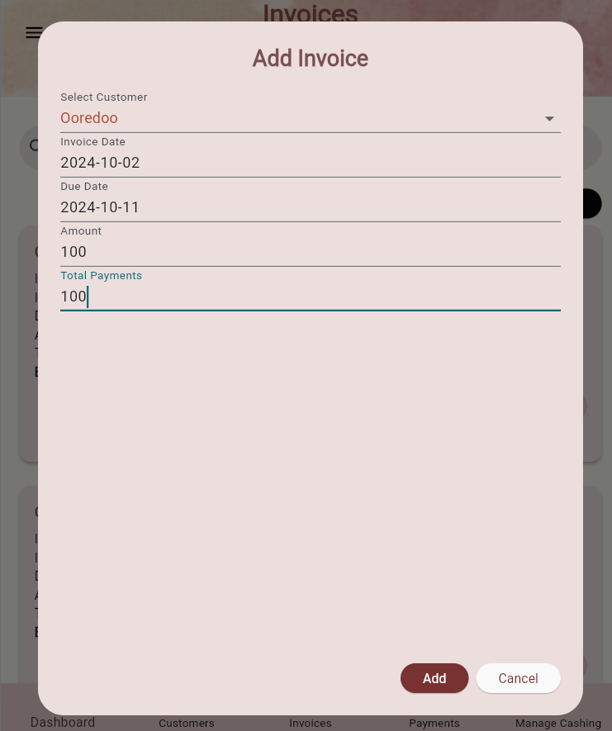

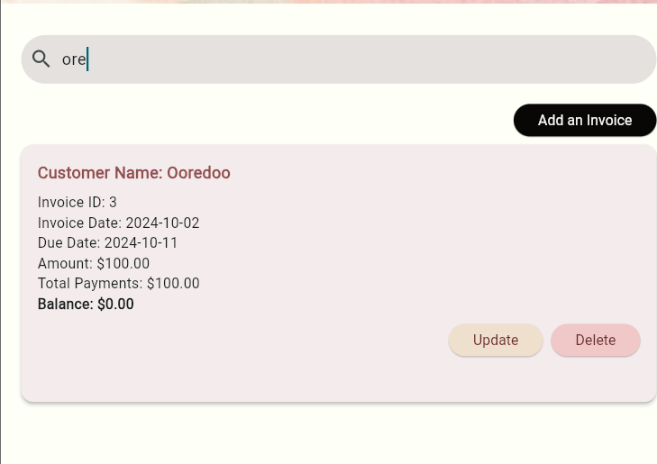

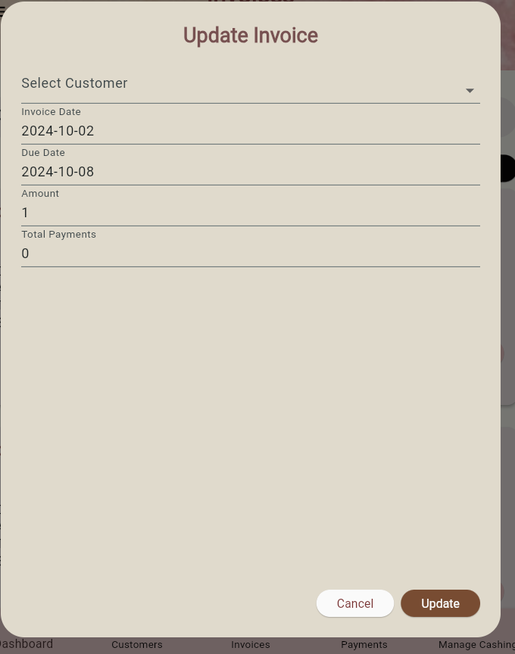

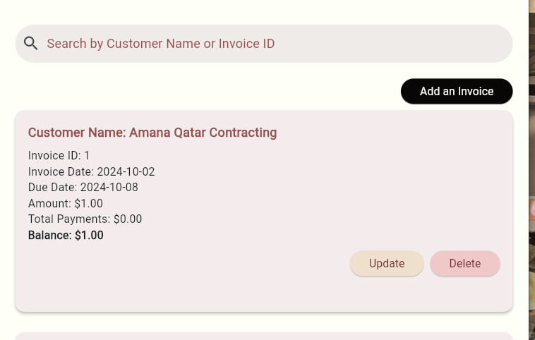

**-U6 - Manage Cashing Cheques**

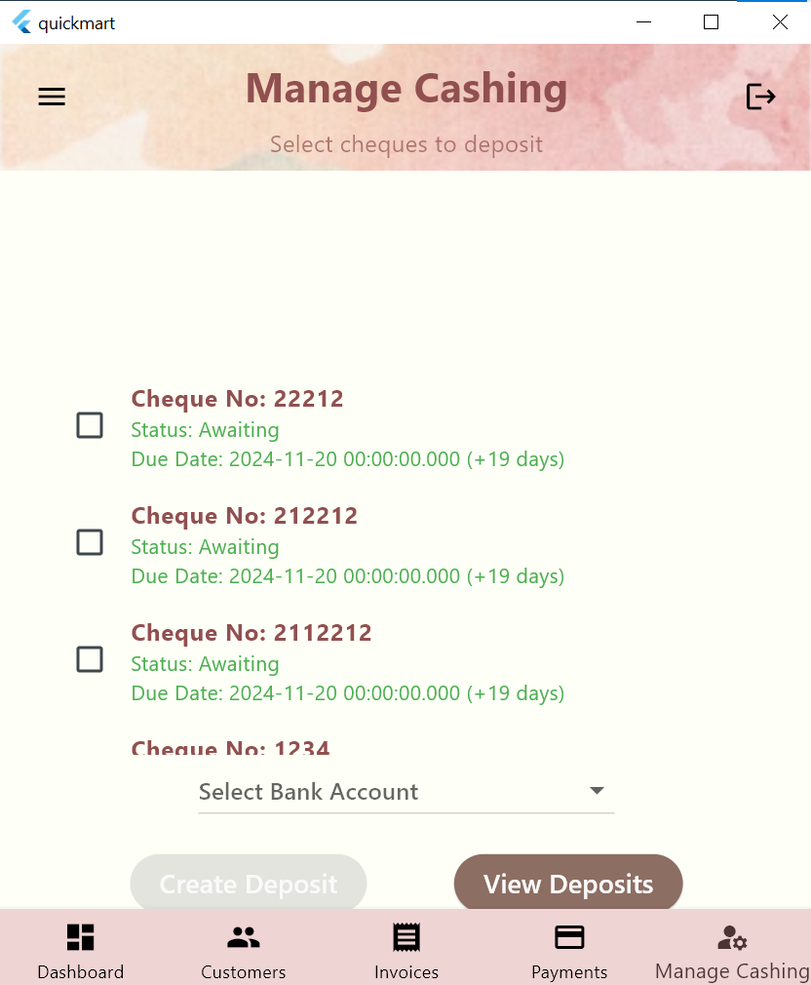

**The cheques no and status and due data are presented and cheques past their due date have their information written in red and the number of days past due are shown**

**You must check or or multiple cheques and choose a bank account to deposite to before making a deposite**

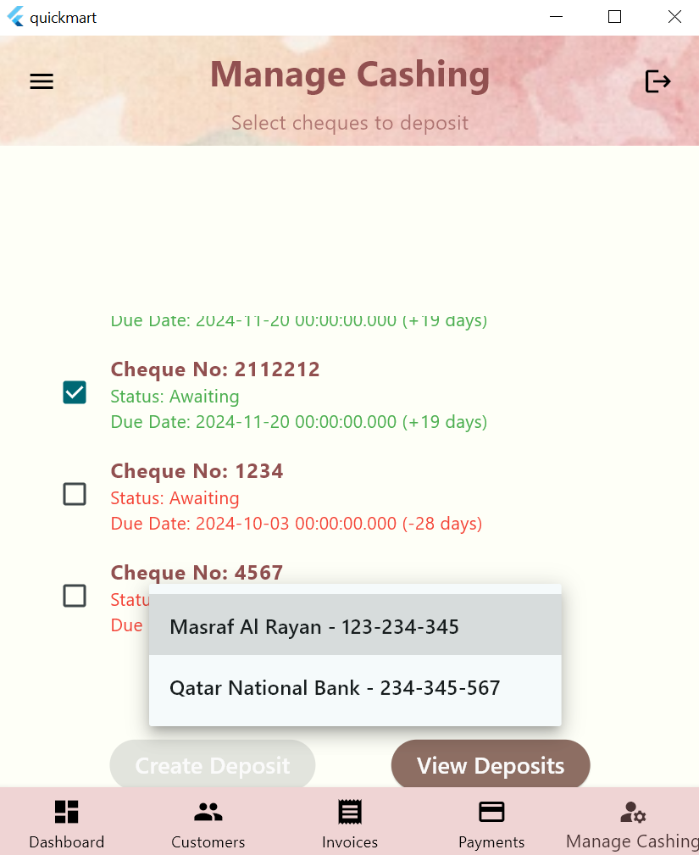

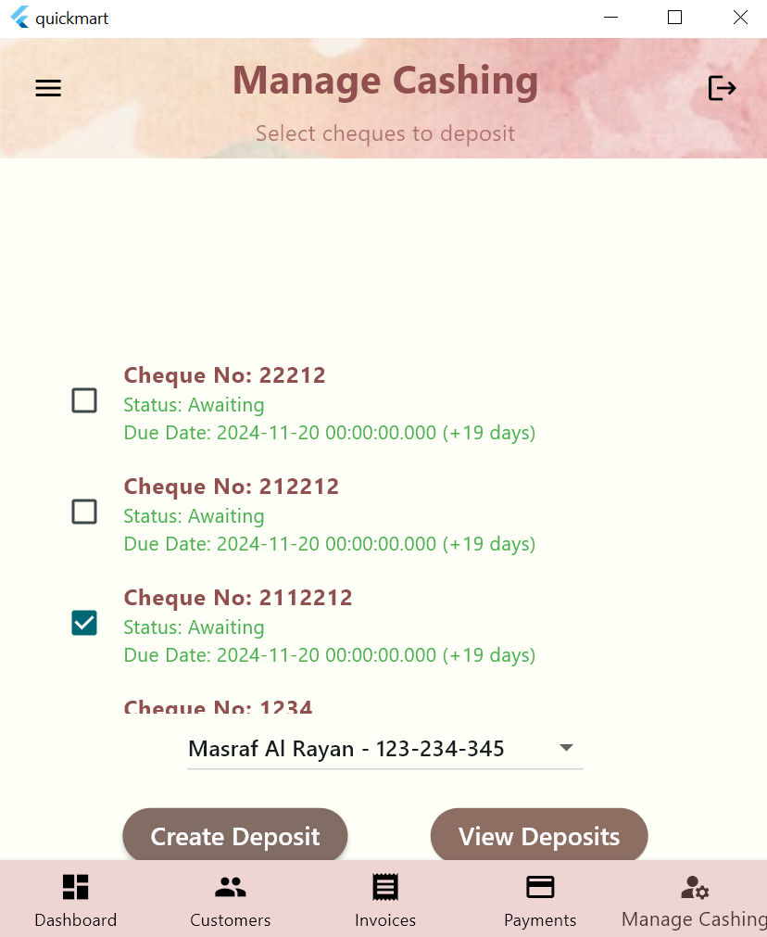

**Deposited cheque is greyed out and u can deposite multiple cheques at the same**

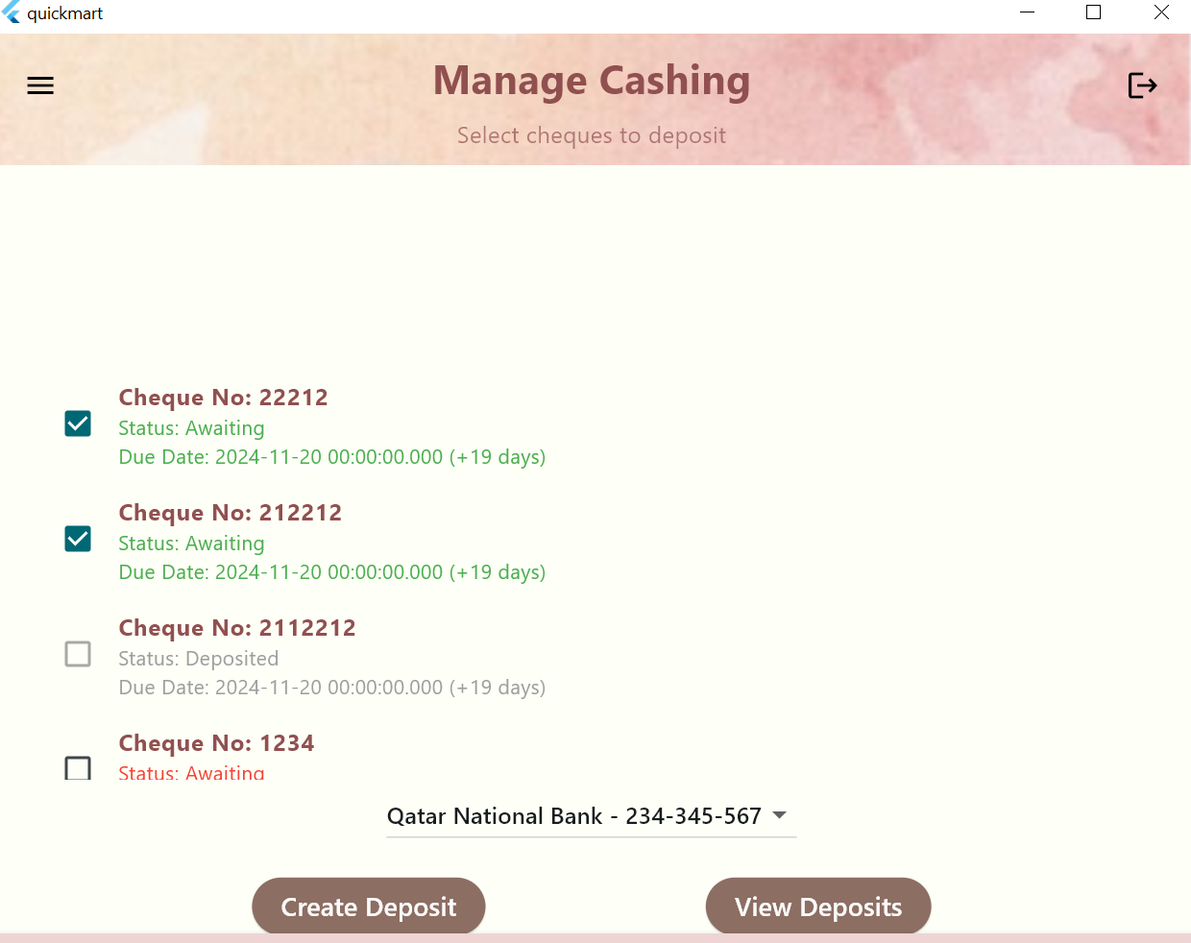

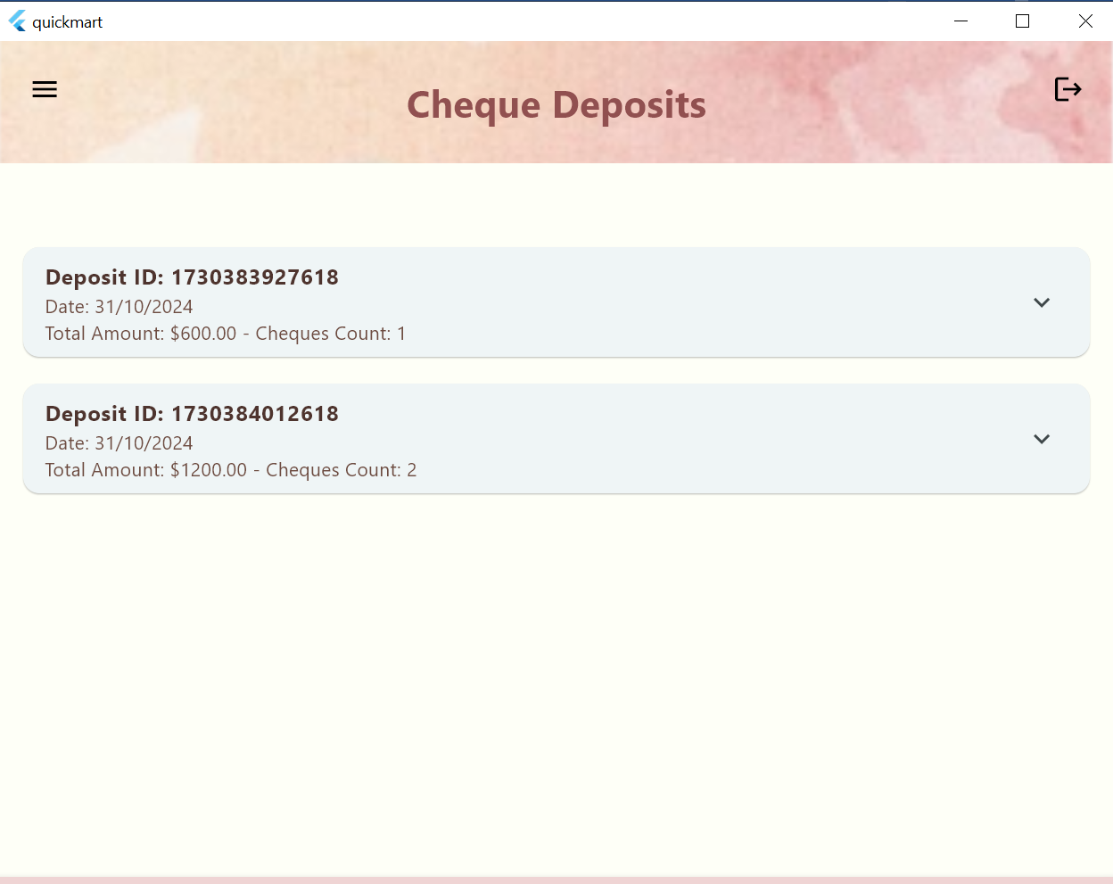

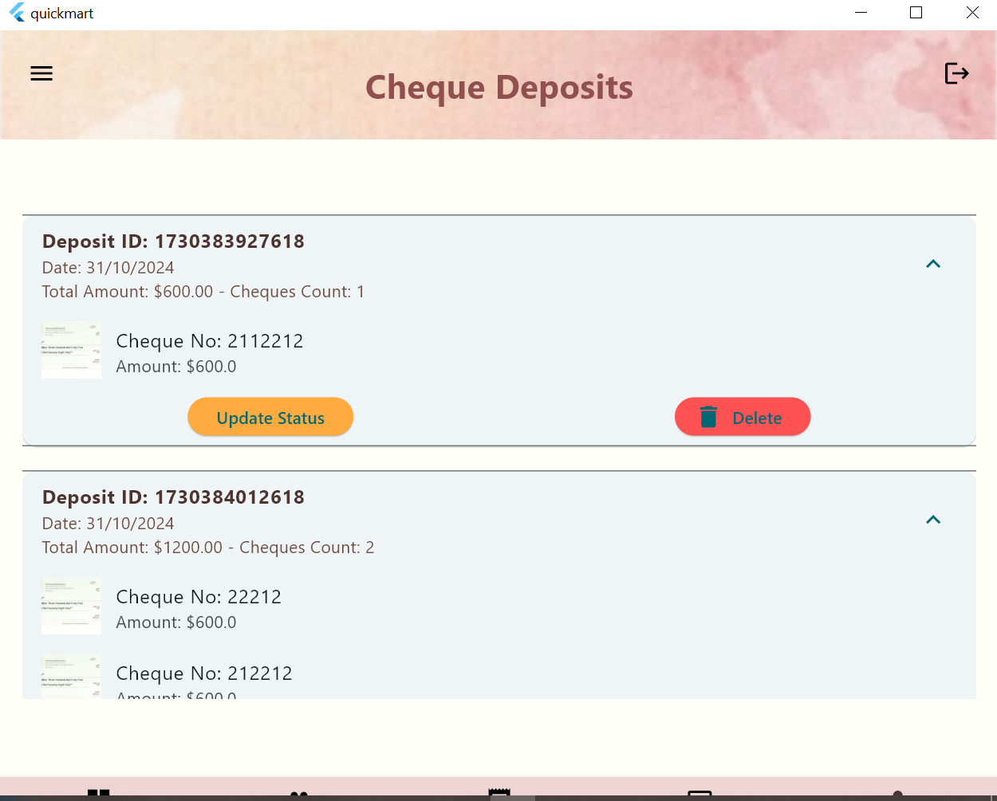

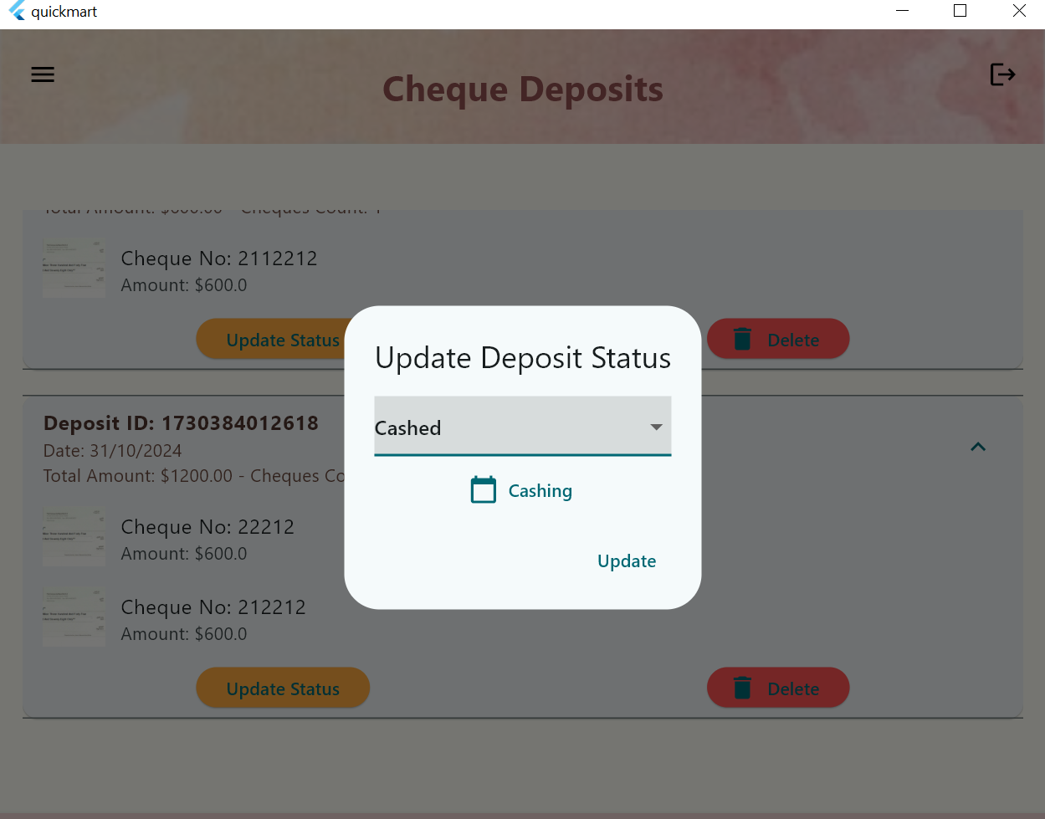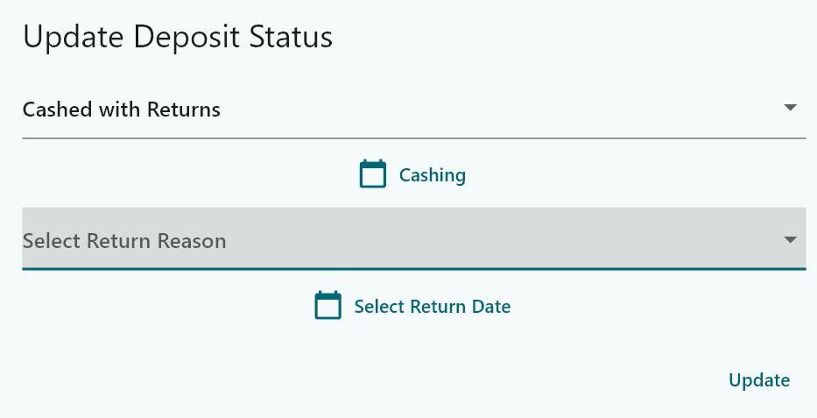

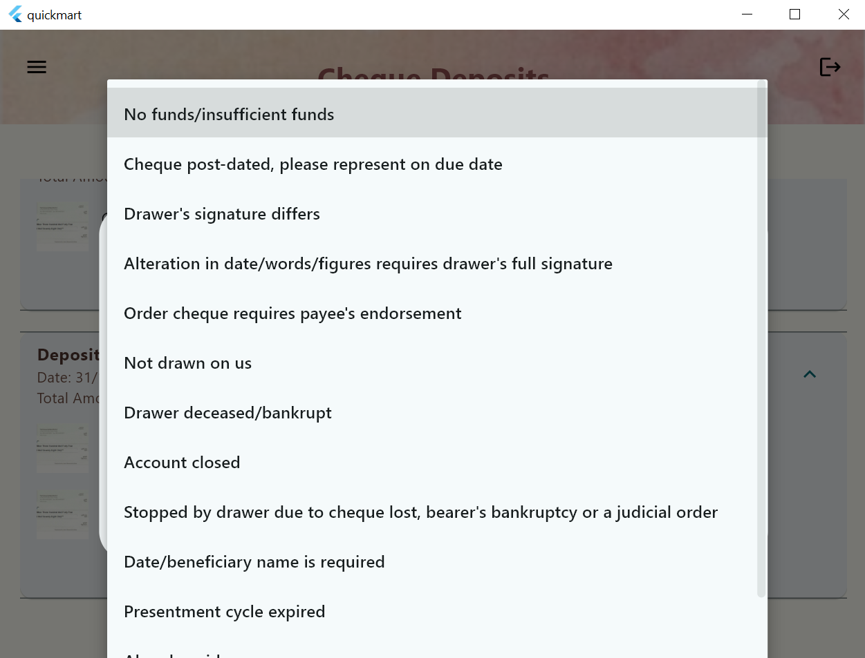

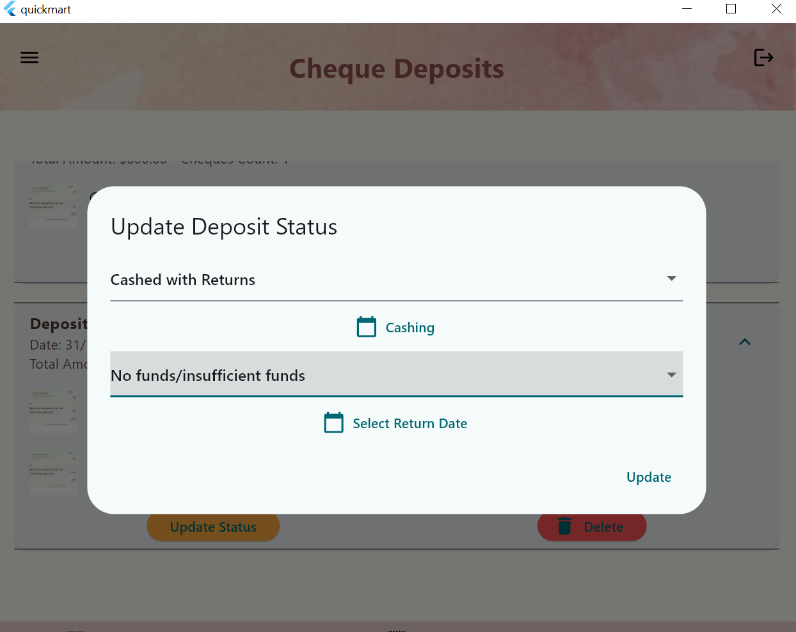

**Cheque report  
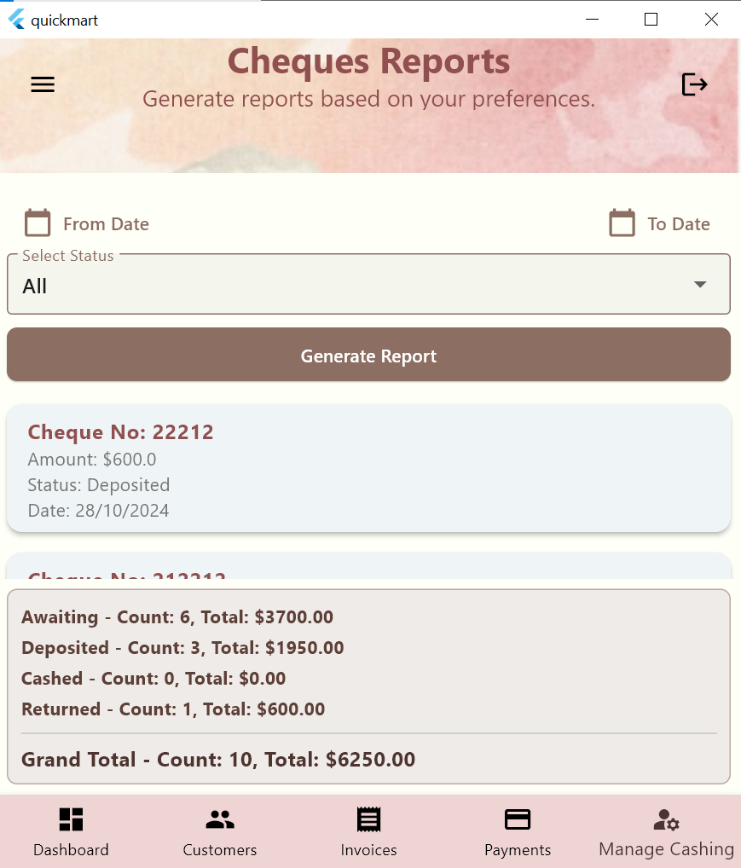**

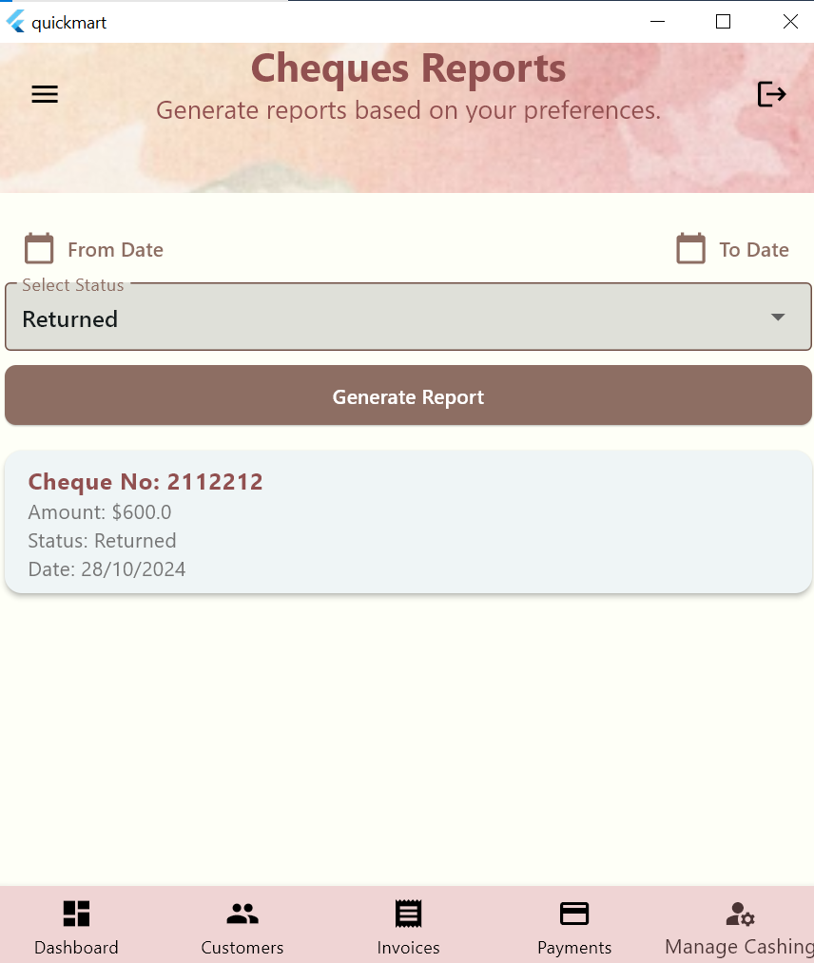

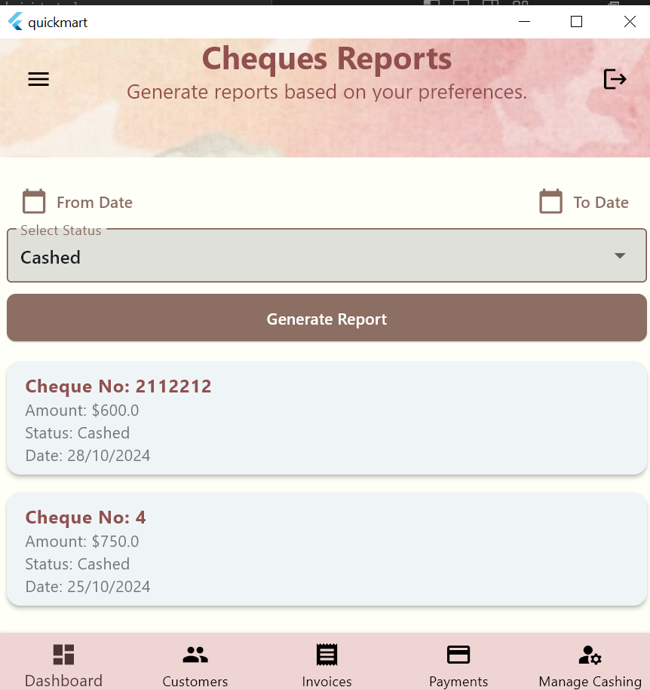

**Filtering using the from date   
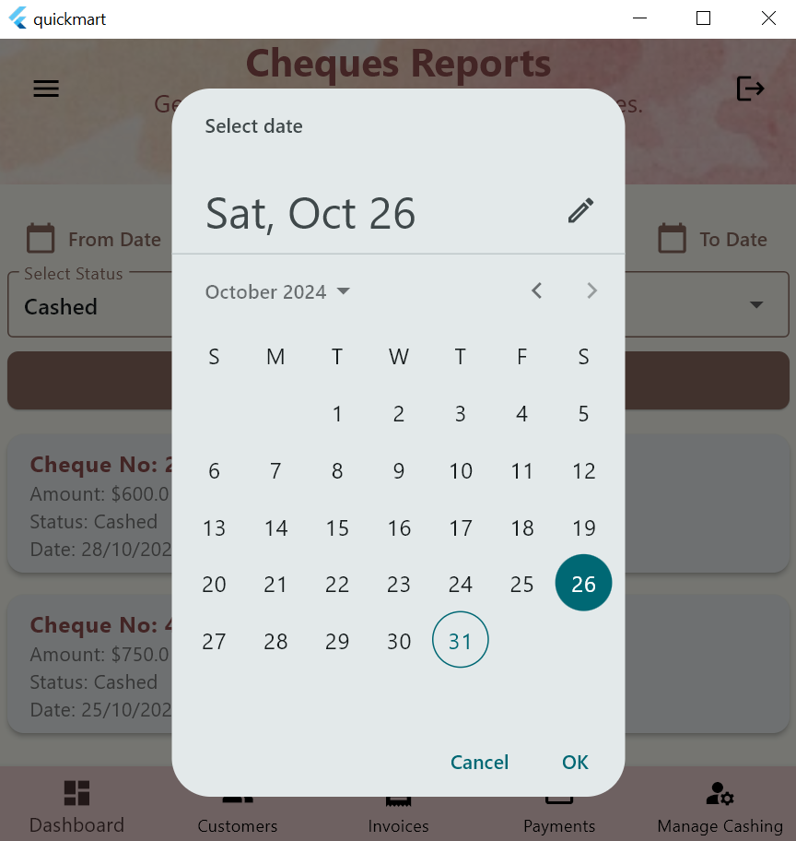**

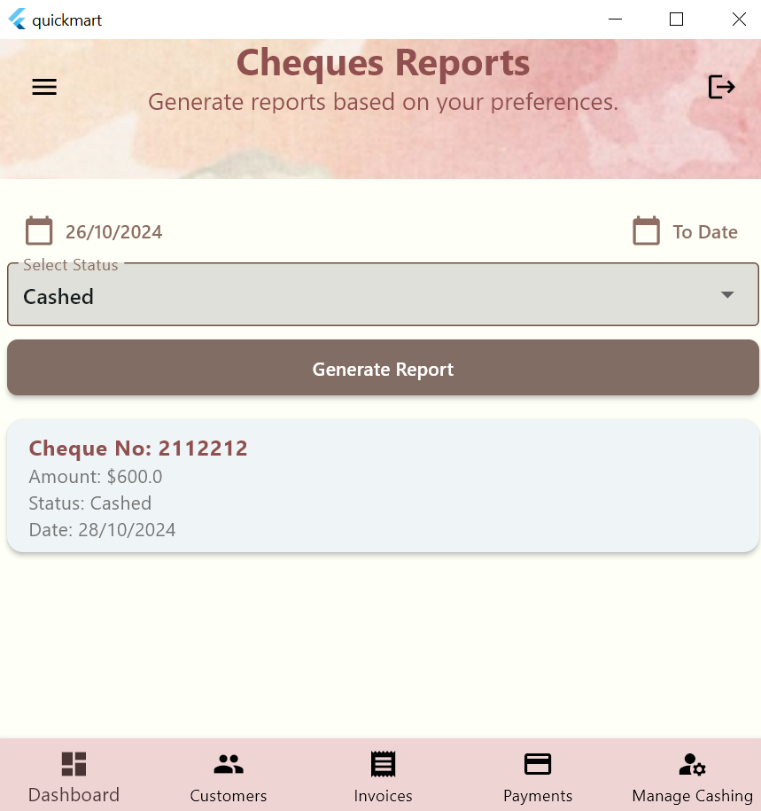

**The delete button deletes the cheque  
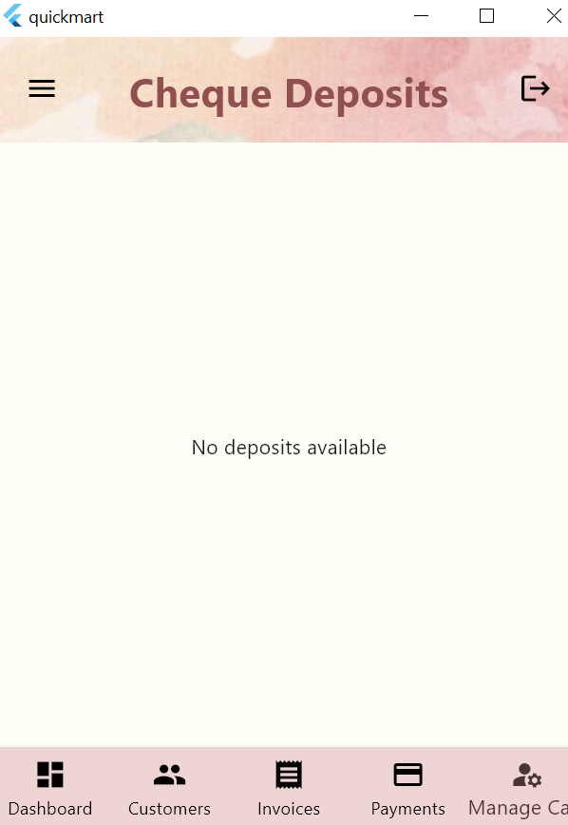**

**Invoice report**

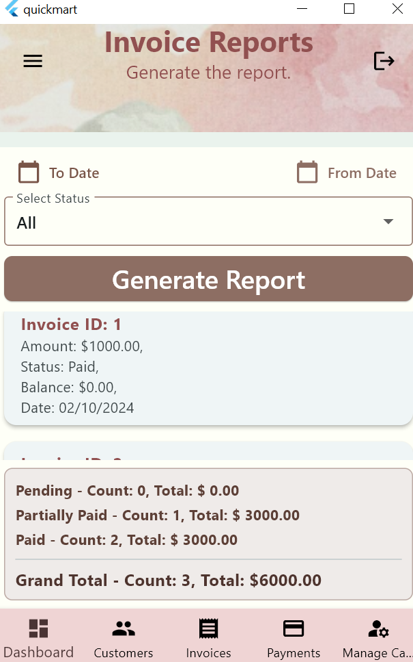

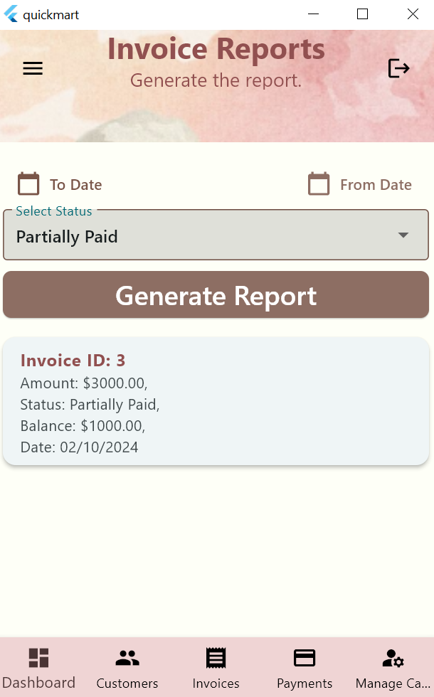

**Payment Screen**

**Searching**

**Add payment only works when you select an invoice**

**Deleting an invoice**

**Update invoice**

**cheque edit**

**Save changes**

* **Add a Payment**

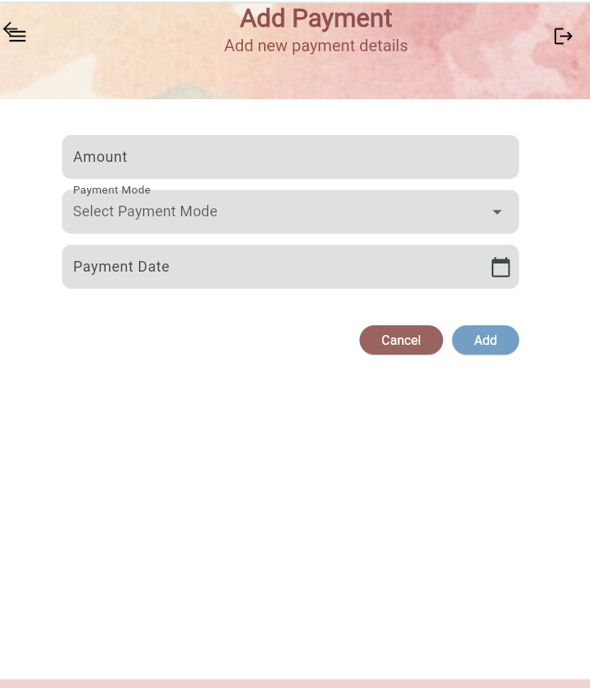

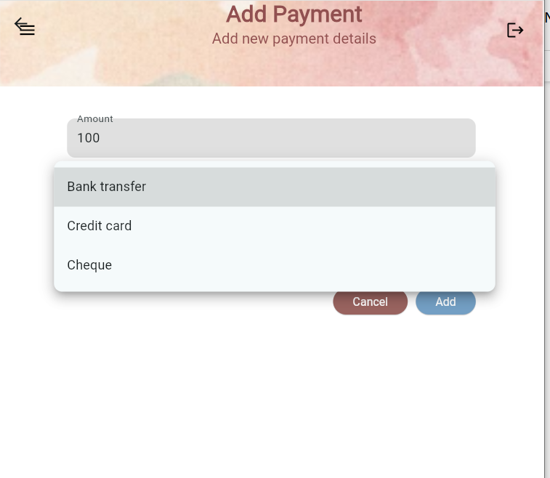

**When cheque is pressed it will give a dialog of cheque to fill**

